Perfect.
Below is the GOLD-STANDARD, step-by-step navigation & workflow for STEP 3 — Attempt Code (Micro-Test Cells).
This is the most important execution step in your whole system.

🧭 STEP 3 — ATTEMPT CODE (MICRO-TEST CELLS)
Goal of Step 3:
Turn your mental model into muscle memory by writing tiny, disposable code and observing what actually happens.
This step is NOT about building programs.
It is about learning how Python behaves.

⏱️ Time Box (STRICT)
- Minimum: 10 minutes
- Maximum: 30 minutes
⛔ If a single cell grows beyond ~5 lines → stop and split it.

🧠 GOLDEN RULES (READ THIS FIRST)
- One idea per cell
- One question per cell
- Cells are disposable
- Errors are expected
- You type first, AI comes later
If you break these rules, learning slows down.

🧩 CONTEXT (WHERE STEP 3 LIVES)
Your notebook structure now looks like this:
[Markdown] Step 2 — Concept: Variable (thinking)
[Code] Step 3.1 Micro-test
[Code] Step 3.2 Micro-test
[Code] Step 3.3 Micro-test
[Code] Step 3.4 Micro-test
...
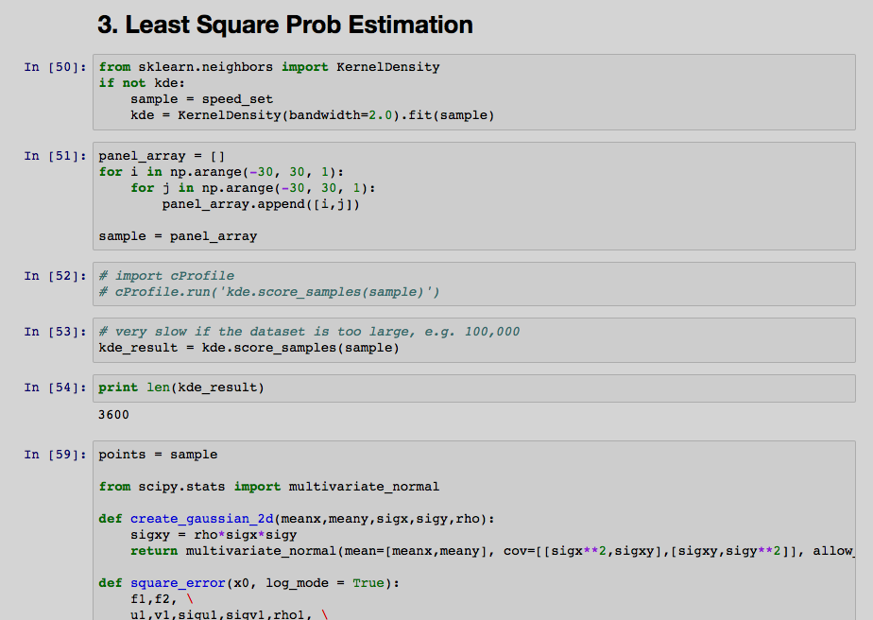
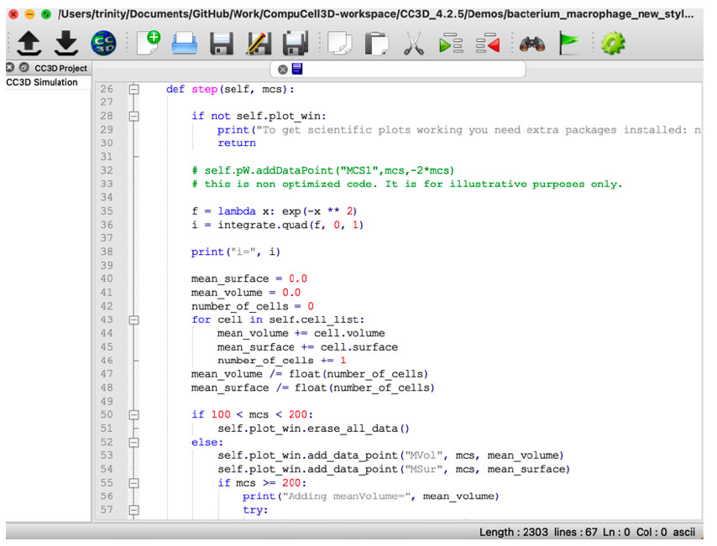
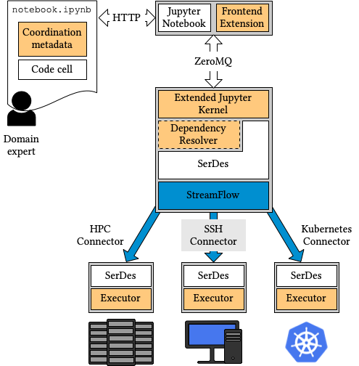

🔢 SUB-STEPS (DO THESE IN ORDER)

3.1 Predict → Write → Run (REQUIRED LOOP)
Every micro-test follows this exact cycle:
- Predict (in your head or comment)
- Write (1–5 lines max)
- Run
- Observe
- Explain what happened
If you skip prediction, you’re guessing — not learning.

3.2 Micro-Test #1: Create a Variable
Cell goal: Can I create a variable?
x = 5
x
After running, ask:
- Did it run without error?
- What is displayed?
- What exists in memory now?
✅ Checkpoint:
You can explain what x refers to.

3.3 Micro-Test #2: Read the Value
Cell goal: Can I use the variable?
y = x + 2
y
Ask:
- Did Python need quotes?
- Did it copy x or reference it?
- What changed in memory?
✅ Checkpoint:
You understand variables can be used in expressions.

3.4 Micro-Test #3: Change the Value
Cell goal: What happens when I reassign?
x = 10
x
Ask:
- Did the old value disappear?
- Is this “updating” or “rebinding”?
- Does y change automatically?
✅ Checkpoint:
You see that names can change what they point to.

3.5 Micro-Test #4: Name vs Value Confusion (ON PURPOSE)
Cell goal: Trigger a beginner confusion.
a = 3
b = a
a = 100
b
Ask:
- Why is b still 3?
- What does this say about names vs values?
🚨 This test prevents weeks of confusion later.

3.6 Micro-Test #5: Type Awareness (Light Touch)
Cell goal: Notice type without studying it yet.
age = 10
type(age)
name = "Collins"
type(name)
Rule:
Do NOT deep-dive into types yet.
Just notice: different values → different kinds.

3.7 Error Cell (MANDATORY)
You must intentionally break something.
age = 10
age + "years"
Let it fail.
Read the traceback slowly.
Ask:
- What line failed?
- What words look unfamiliar?
- What does Python complain about?
⛔ Do NOT fix it yet
⛔ Do NOT ask AI yet
✅ Checkpoint:
You can point to the exact problem line.

🧠 HOW MANY CELLS IS “RIGHT”?
For one tiny concept (like variables):
- ✅ 5–10 code cells
- ❌ Not 1 giant cell
- ❌ Not 30 tiny ones
If you exceed 10 → stop. You’re drifting.

🧹 CLEANUP RULE (IMPORTANT)
After finishing Step 3:
- ❌ Do NOT delete cells
- ❌ Do NOT “optimize” code
- ✅ Leave raw, messy, honest attempts
This notebook is a lab notebook, not a product.

🏁 OUTPUT OF STEP 3 (MANDATORY)
By the end of Step 3, you must be able to say:
✅ I can create, read, and change variables
✅ I understand name vs value
✅ I’ve seen at least one error
✅ I can explain what each cell did
If not → repeat only the failing micro-test, not all of Step 3.

🔑 BIG TAKEAWAY (WRITE THIS DOWN)
Small code, many cells, fast feedback.
This is how beginners become dangerous (in a good way).

What’s next in your Navigation Map:
➡️ Step 4 — Use AI as Reviewer Mode on YOUR code
(not generator, not teacher — reviewer)
When you’re ready, say “step 4” and we’ll lock that in properly.

